- Bluebook Page59 May 2019 Variant One examination:

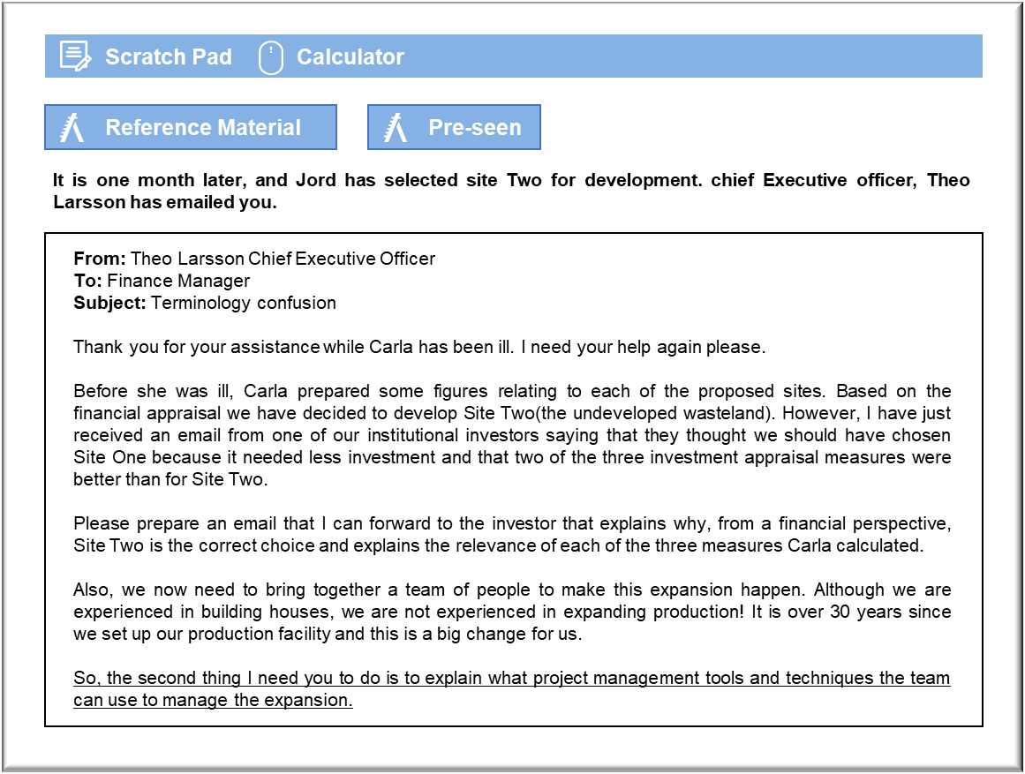

MANAGEMENT CASE STUDY MAY 2019 EXAM ANSWERS

Variant1 Task3
These answers have been provided by CIMA for information purposes only. The answers created are indicative of a response that could be given by a good candidate. They are not to be considered exhaustive, and other appropriate relevant responses would receive credit.

CIMA will not accept challenges to these answers on the basis of academic judgement.

Email to shareholder
The comparison lists three performance measures for each site. The concern appears
to be that the site with the better NVP has the poorer discounted payback and IRR.
That problem is readily dealt with because NVP is the only criterion that directly
measures the impact of a decision on shareholder wealth. Site Two has the higher NPV
and so it is the superior investment. Any counterarguments based on IRR or
discounted payback will be confusing.
IRR measures the return that is being earned on the funds invested in the project. Any
project that has an IRR that exceeds the required rate of return will have a positive
NPV. That means that Jord should accept both projects if it can. Clearly it cannot, in
this case, because the two sites are mutually exclusive investments. Acquiring one
would mean that there was no need for the other.
When comparing mutually exclusive investments, IRR can give misleading results
because it ignores the scale of a project. Scale is usually related to the amount invested
and the duration of the project. In this case, Site One offers a higher rate of return, but
on an initial investment that is C$2 million smaller. In absolute terms, Site Two offers
a larger increase in wealth because it gives a good return on a larger initial investment.
The discounted payback of Site One is shorter, but that does not necessarily make it a
better investment. Certainly, a project that offers a rapid discounted payment can be
expected to offer significant inflows in the early years of the project. Companies may
consider the payback criterion when aiming to manage their long-term cash flows.
However, a more rapid payback does not outweigh a larger NPV because discounted
payback is not a direct measure of the impact on shareholder wealth.

Project team to manage expansion, tools and techniques
Jord will need to employ project management tools and techniques to ensure the
expansion project goes well.
This will involve recruiting the right members of staff to a team of people, brought
together to action the expansion. The team may involve current members of staff and
external people brought in to help where we do not have the expertise or manpower
alone. Ideally, the team would comprise people with different skills and abilities in the
right balance to get the job done. It may be beneficial to include members of staff from
all five of our operating divisions, as all divisions will be impacted to some extent by
the expansion as, whilst they type of work they are doing shouldn’t change, the amount
of work passing through each division will increase by up to 25% compared to what it
is used to although it is clearly recognised that additional staff will need to be recruited
for each division.
Once the team is congregated there are several tools that can be used to assist the
process. Risks will need to be assessed and managed using tools such as ‘TARA’ where
risks are assessed for probability and impact with plans made accordingly to transfer,
avoid, reduce or accept the risks arising from operations.
A work breakdown schedule will be useful to organise the work to be done into more
manageable sections and a Gantt chart could show a useful visual representation of the
work schedule, including potentially elements of the project that are inter-dependent.
A Gantt chart aids clarity and makes complicated projects simpler to view and manage.
May 2019 7 Management Case Study Exam
Scenario planning can be a useful way to understand how uncertainties may impact on
the final project outcome and in this scenario could be helpful in ascertaining how high
costs could go if certain circumstances arise. If certain scenarios are very expensive
then we will need to act to make sure they don’t arise.
Finally, project management software could be very useful to Jord, as an organisation
very comfortable and familiar with using software in house scheduling it could be
extremely helpful to use similar software systems adapted for this project. Software
can be useful to enhance collaborative working across the project with document
sharing, budget management, time scheduling, monitoring and communication all
useful roles that can be completed with effective software.

